https://sql-ex.ru/learn_exercises.php#answer_ref
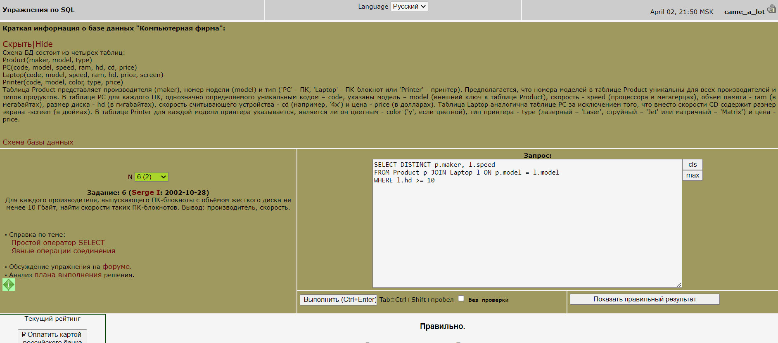
1_№6(2)
SELECT DISTINCT p.maker, l.speed
FROM Product p JOIN Laptop l ON p.model = l.model
WHERE l.hd >= 10
2_№7(2)
SELECT p.model, p2.price
FROM Product p JOIN PC p2 ON p.model = p2.model
WHERE p.maker LIKE 'B'
UNION
SELECT p.model, l.price
FROM Product p JOIN Laptop l ON p.model = l.model
WHERE p.maker LIKE 'B'
UNION
SELECT p.model, p1.price
FROM Product p JOIN Printer p1 ON p.model = p1.model
WHERE p.maker LIKE 'B'

3_№8(2)
SELECT MAKER
FROM PRODUCT
WHERE TYPE LIKE 'PC'
EXCEPT
SELECT MAKER
FROM PRODUCT
WHERE TYPE LIKE 'LAPTOP'

4_№14(2)
SELECT S.CLASS, S.NAME, C.COUNTRY
FROM SHIPS S JOIN CLASSES C ON S.CLASS = C.CLASS
WHERE C.NUMGUNS >= 10

5_№15(2)
SELECT HD
FROM PC
GROUP BY HD
HAVING COUNT(HD) >=2

6_№16(2)
SELECT P.MODEL, P2.MODEL, P.SPEED, P.RAM
FROM PC P JOIN PC P2 ON P.SPEED = P2.SPEED
WHERE P.RAM=P2.RAM AND P.MODEL > P2.MODEL
ORDER BY RAM DESC

7_№17(2)
SELECT DISTINCT P.TYPE,P.MODEL,L.SPEED
FROM LAPTOP L
JOIN PRODUCT P on L.MODEL=P.MODEL
WHERE L.SPEED<(SELECT MIN(SPEED)
FROM PC)

8_№18(2)
SELECT DISTINCT P.MAKER, PR.PRICE
FROM product P JOIN PRINTER PR ON P.MODEL=PR.MODEL
WHERE PR.COLOR = 'Y' AND PR.PRICE = (
SELECT MIN(PRICE) FROM PRINTER
WHERE COLOR = 'Y')

9_№20(2)
SELECT MAKER, COUNT(MODEL)
FROM PRODUCT
WHERE TYPE = 'PC'
GROUP BY MAKER
HAVING COUNT (MODEL) >= 3

10_№23(2)
SELECT DISTINCT MAKER
FROM PRODUCT P JOIN PC PC ON P.MODEL=PC.MODEL
WHERE PC.SPEED>=750 AND P.MAKER IN
( SELECT MAKER
FROM PRODUCT P JOIN LAPTOP L ON P.MODEL=L.MODEL
WHERE L.MODEL>=750)

11_№24(2)
SELECT MODEL
FROM (
SELECT MODEL, PRICE
FROM PC
UNION
SELECT MODEL, PRICE
FROM LAPTOP
UNION
SELECT MODEL, PRICE
FROM PRINTER ) t1
WHERE PRICE = (
SELECT MAX(PRICE)
FROM (
SELECT PRICE
FROM PC
UNION
SELECT PRICE
FROM LAPTOP
UNION
SELECT PRICE
FROM PRINTER ) t2
)
12_№27(2)
SELECT P.MAKER, AVG(P2.HD)
FROM PRODUCT P JOIN PC P2 ON P.MODEL = P2.MODEL
WHERE P.MAKER IN ( SELECT MAKER
FROM PRODUCT
WHERE TYPE = 'PRINTER')
GROUP BY P.MAKER

13_№28(2)
SELECT COUNT(CNT)
FROM
(
SELECT MAKER, COUNT(MODEL) AS CNT
FROM PRODUCT
GROUP BY MAKER
) T
WHERE CNT = 1

14_№34(2)
SELECT NAME
FROM SHIPS S JOIN CLASSES C ON S.CLASS = C.CLASS
WHERE S.LAUNCHED >= 1922 AND C.DISPLACEMENT > 35000 AND C.TYPE LIKE 'BB'

15_№35(2)
SELECT MODEL, TYPE
FROM PRODUCT
WHERE UPPER(MODEL) NOT LIKE '%[^A-Z]%'
OR MODEL NOT LIKE '%[^0-9]%'

16_№43(2)
SELECT NAME
FROM BATTLES
WHERE YEAR(DATE) NOT IN
(SELECT LAUNCHED
FROM SHIPS)

17_№46(2)
SELECT S.NAME, C.DISPLACEMENT, C.NUMGUNS
FROM OUTCOMES O JOIN SHIPS S ON O.SHIP=S.NAME
JOIN CLASSES C ON S.CLASS=C.CLASS
WHERE O.BATTLE LIKE 'Guadalcanal'

18_№48(2)
SELECT C.CLASS
FROM CLASSES C
LEFT JOIN SHIPS S ON C.CLASS = S.CLASS
WHERE C.CLASS IN (SELECT SHIP FROM OUTCOMES WHERE RESULT LIKE 'SUNK') OR
S.NAME IN (SELECT SHIP FROM OUTCOMES WHERE RESULT LIKE 'SUNK')

19_№52(2)
SELECT NAME
FROM SHIPS S LEFT JOIN CLASSES C ON S.CLASS=C.CLASS
WHERE COUNTRY LIKE 'JAPAN' AND TYPE LIKE 'bb' AND NUMGUNS >=9 AND BORE < 19 AND DISPLACEMENT <=65000

20_№53(2)
SELECT ROUND(AVG(NUMGUNS),2)
FROM CLASSES
WHERE TYPE LIKE 'bb'

21_№55(2)
SELECT C.CLASS, T.YEAR1
FROM CLASSES C
LEFT JOIN
(SELECT CLASS, MIN(LAUNCHED) AS YEAR1
FROM SHIPS
GROUP BY CLASS
) AS T ON C.CLASS = T.CLASS

22_№56(2)
SELECT C.CLASS, COUNT(SO.SHIP)
FROM CLASSES C
LEFT JOIN
(
SELECT O.SHIP, S.CLASS
FROM OUTCOMES O
LEFT JOIN SHIPS S ON S.NAME = O.SHIP
WHERE RESULT = 'SUNK'
) AS SO ON SO.CLASS = C.CLASS OR SO.SHIP = C.CLASS
GROUP BY C.CLASS

23_№61(2)
SELECT SUM(INC1)
FROM
(SELECT POINT, SUM(INC) as INC1 FROM
INCOME_O
GROUP BY POINT
UNION
SELECT POINT, -SUM(OUT) as INC2 FROM
OUTCOME_O
GROUP BY POINT
) AS T

24_№63(2)
SELECT NAME
FROM PASSENGER
WHERE ID_PSG IN
(SELECT ID_PSG FROM PASS_IN_TRIP
GROUP BY PLACE, ID_PSG
HAVING COUNT(*)>1)

25_№70(2)
SELECT BATTLE, COUNTRY, COUNT (COUNTRY) AS CNT
FROM OUTCOMES O JOIN SHIPS S ON O.SHIP=S.NAME
JOIN CLASSES C ON S.CLASS=C.CLASS
GROUP BY BATTLE, COUNTRY
HAVING COUNT (COUNTRY) >=3

26_№71(2)
SELECT P.MAKER
FROM PRODUCT P
LEFT JOIN PC ON PC.MODEL = P.MODEL
WHERE P.TYPE = 'PC'
GROUP BY P.MAKER
HAVING COUNT(P.MODEL) = COUNT(PC.MODEL)

27_№77(2)
SELECT TOP 1 WITH TIES CNT, DATE
FROM (
SELECT COUNT (DISTINCT P.TRIP_NO) AS CNT, DATE
FROM PASS_IN_TRIP P
JOIN TRIP T ON P.TRIP_NO = T.TRIP_NO
WHERE T.TOWN_FROM = 'ROSTOV'
GROUP BY P.TRIP_NO, DATE) T
ORDER BY CNT DESC

28_№80(2)
SELECT DISTINCT MAKER
FROM PRODUCT
WHERE MAKER NOT IN (SELECT MAKER
FROM PRODUCT
WHERE TYPE='PC' AND MODEL NOT IN (
SELECT MODEL
FROM PC))

29_№85(2)
SELECT MAKER
FROM PRODUCT
GROUP BY MAKER
HAVING COUNT(DISTINCT TYPE) = 1
AND (MIN (TYPE) = 'PRINTER' OR (MIN(TYPE) = 'PC' AND COUNT(MODEL) > 2))

30_№90(2)
SELECT MAKER, MODEL, TYPE
FROM (SELECT MAKER, MODEL, TYPE,
ROW_NUMBER() OVER (ORDER BY MODEL) RN1,
ROW_NUMBER() OVER (ORDER BY MODEL DESC) RN2
FROM PRODUCT
) t
where RN1 > 3 and RN2 > 3

